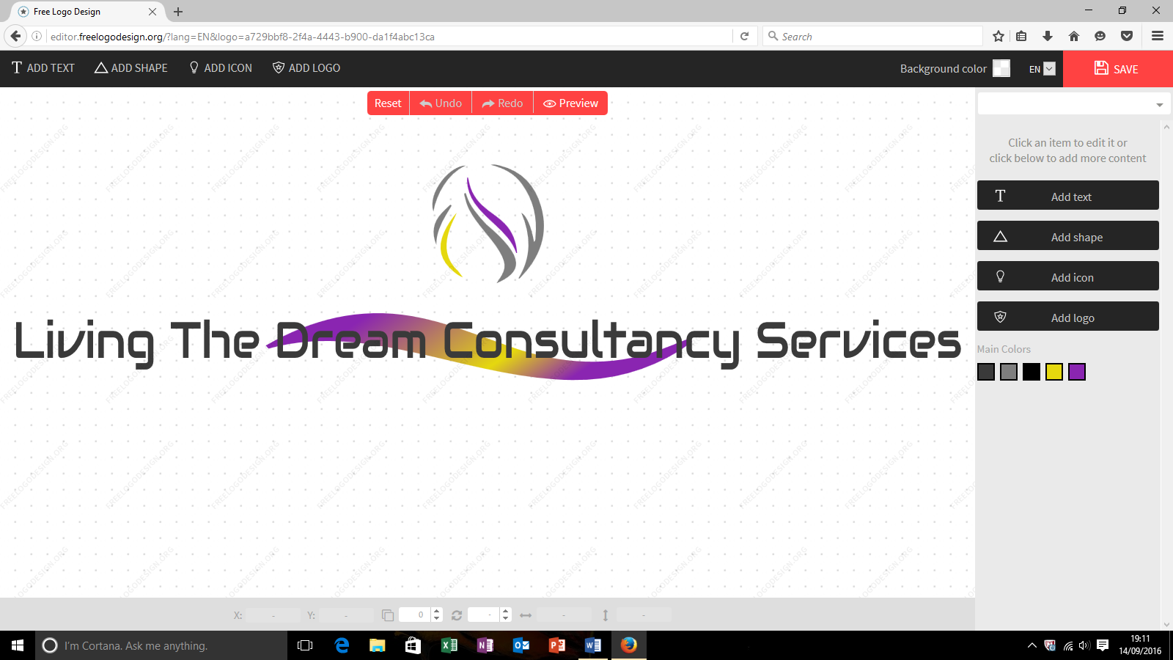



[ltdconsultancyservices@gmail.com](mailto:ltdconsultancyservices@gmail.com)

Thank you for vising our site. I have every confidence that you will be able to find programmes and workshops to suit your individual and organisational needs.

As you are here, it proves your commitment and investment in yourself and others. Great!

Below are a list of programmes and workshops commencing September 2019 and January – December 2020.

**Pastoral and Support staff CPD – Counselling skills**

**ONE DAY WORKSHOP – (three members of staff minimum)**

* £130 pp

**FIVE DAY WORKSHOP – (six members of staff minimum)**

* £270 pp for six people
* £210 pp for nine people

**One day workshop:**

This workshop will provide your chosen delegates with an experiential learning of effective tools to become a skilled helper. Skills which can be employed in their day to day working with students and colleagues alike.

Our workshops also provide opportunities for personal and professional growth and development. Both of which can be re-deployed back into the workplace, subsequently producing a viable resource and profitable investment for the management team.

Participants involved will be provided with the tools to have meaningful conversations. Making those involved, feel listened to, heard and understood. Endorsing opportunities for reflection, participation and positive engagement with those whom otherwise would be deemed hard to reach.

This one-day workshop will be the basis of the first steps to creating a caring and nurturing environment in the workplace.

**Five-day workshop**

This programme of study familiarizes participants with a primary knowledge base of counselling skills which will transform the effectiveness of outcomes for the workplace. Delegates will gain transferable skills with a certificate of competency demonstrating their areas of ability.

The five-day workshop provides opportunities for individuals to obtain information, resources and skills which can be disseminated throughout departments in the workplace. Thus, promoting a cost-effective solution to training.

Each day will open-up an area of expertise in the way we communicate with other, for a desired and positive outcome. Reducing the necessity for alternative provisions to be put in place.